C3 Project: Restaurant Finder: Part 1

***Use Case Diagram***

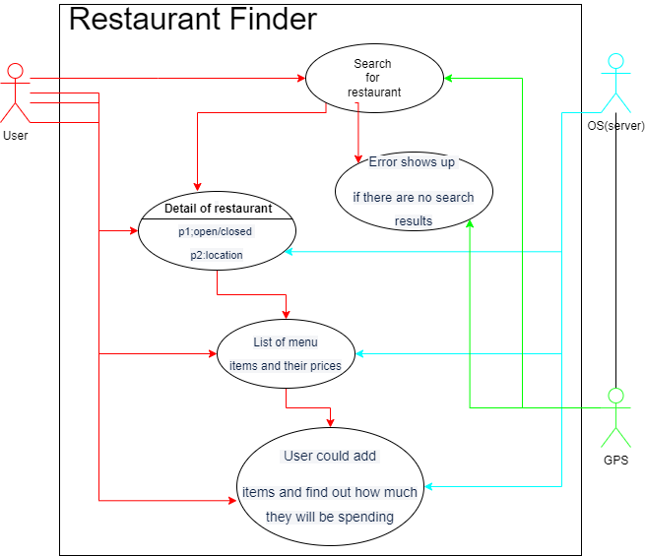

***Activity Diagram***

